SLE-3: Architectural Design (Full C4 Model)
Course: 02AML204 – Introduction to Artificial Intelligence

PRN | 25UAM100 | Name | Tejas Magdum
Division | B
1. System Title & Short Description
BFS / DFS Graph Search System is a search-based system that finds a path from a starting node to a goal node in a graph. The user provides the graph and selects a search method. BFS explores nodes level by level, while DFS explores one branch deeply before backtracking. The system tracks visited nodes, checks the goal, and produces the search/path result.
2. Context Diagram (Level 1)
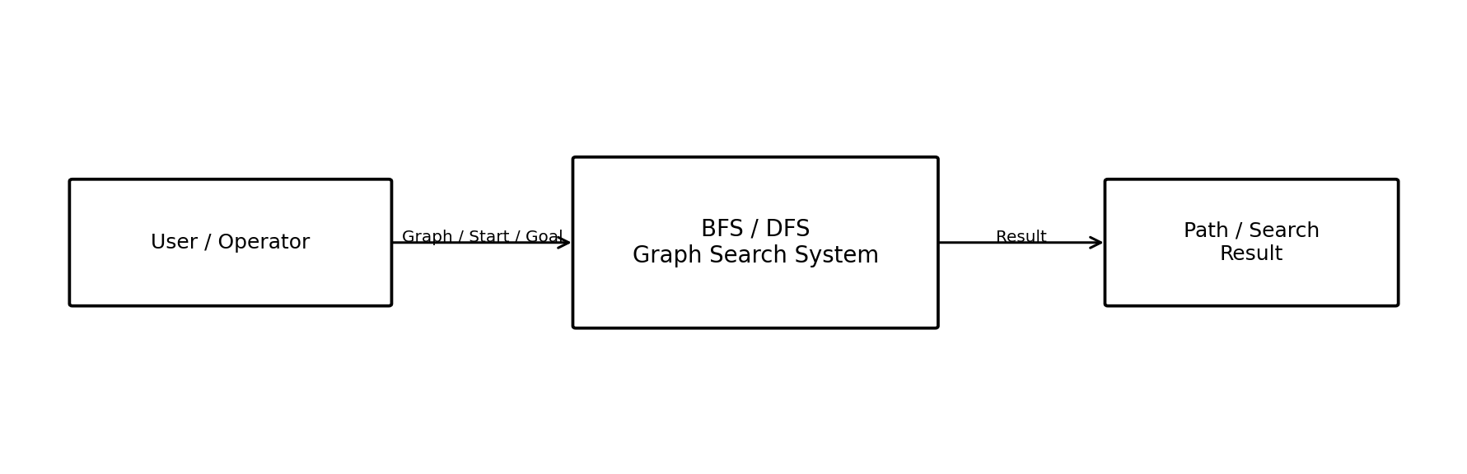
The user supplies the graph, starting node, goal node, and search choice. The BFS/DFS Graph Search System processes the input and returns the resulting search/path information to the user.
3. Container Diagram (Level 2)
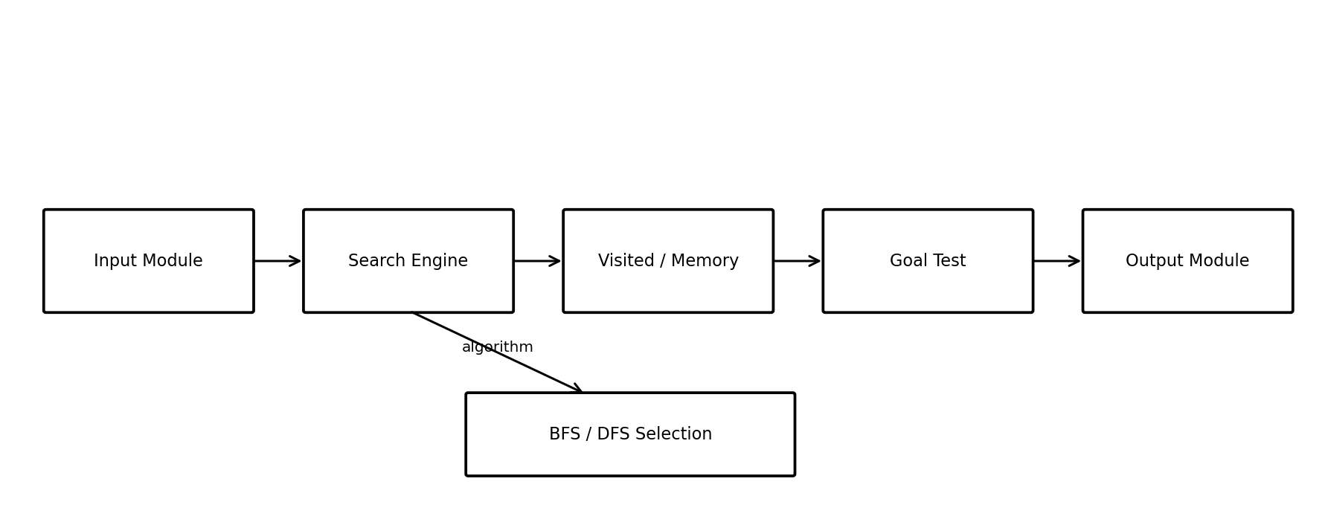
Input Module: Accepts the graph, start node, goal node, and BFS/DFS selection.
Search Engine: Executes the selected BFS or DFS algorithm.
Visited / Memory: Stores already visited nodes to avoid repeated processing.
Goal Test: Checks whether the current node is the required goal.
Output Module: Displays the traversal/path and final search result.
4. Component Diagram (Level 3)
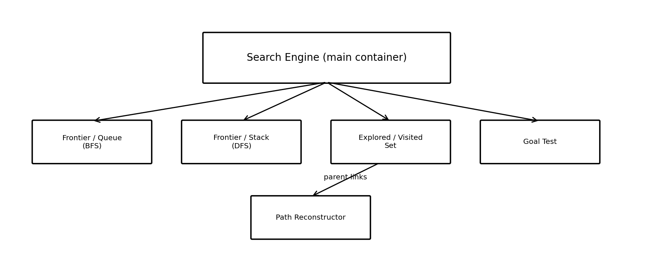
The Search Engine is divided into small components. BFS uses a queue frontier and DFS uses a stack frontier. The explored/visited set prevents repeated visits, the goal test identifies the target, and the path reconstructor uses parent information to build the final path.
5. Code Level Overview (Level 4)
class Node : Represents a graph node and its connections.
class Graph : Stores vertices and edges of the search problem.
def bfs(graph, start, goal) : Performs breadth-first search.
def dfs(graph, start, goal) : Performs depth-first search.
def goal_test(node, goal) : Checks whether the goal is reached.
def reconstruct_path(parent, start, goal) : Builds the final path.
6. Design Decisions
The architecture keeps input, search, memory, goal checking, and output separate so each responsibility is easy to understand and test. BFS and DFS share the same Search Engine structure while using different frontier data structures. The design is intentionally kept small and readable, as required for a search/maze system.
7. AI Contribution Note
AI tools used (if any): ChatGPT for understanding the C4 structure, organizing the architecture, and improving explanations/diagram labels.
What AI helped with: Suggested a clear 4-level C4 structure and concise documentation.
What I did myself: Selected the BFS/DFS system, verified the modules and algorithm responsibilities, reviewed the diagrams, and can explain the design.
8. Conclusion
The C4 model helped represent the BFS/DFS search system from the overall user view down to classes and functions. The architecture shows how inputs move through the search engine, memory, goal test, and output. I learned how separating responsibilities makes a search system easier to understand, explain, and maintain.

